Lab 1
Natnael Kebede
- Screen capture showing the arrival time of the the ICMP traffic in Wireshark
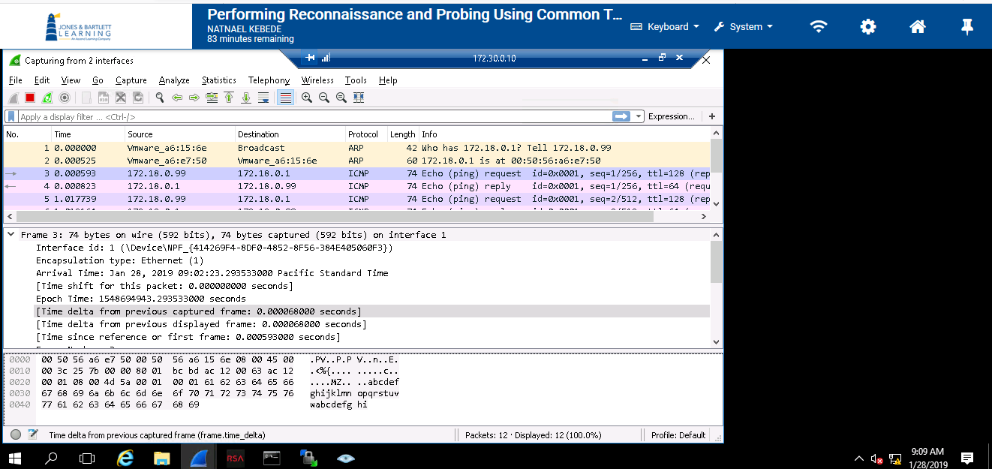
- Screen captures showing the filename of the attachment in the collection using NetWitness inverstigator tool.
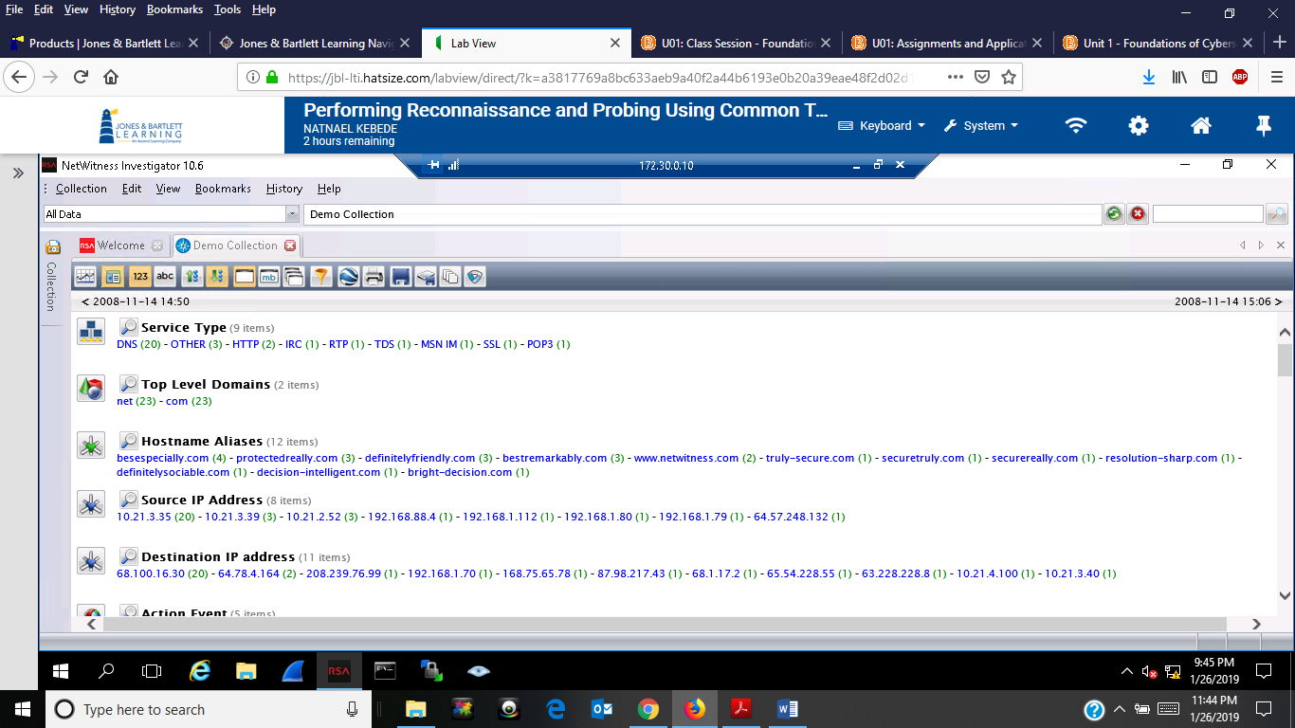
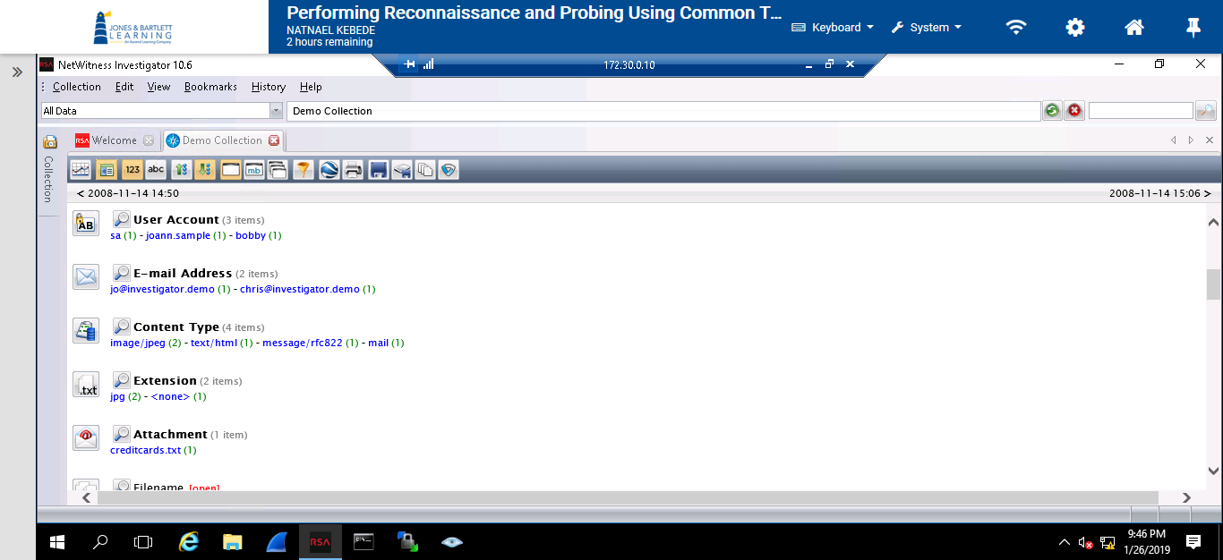

- Screen shot showing the recorder results while using the show interface Cisco command In PuTTy terminal consule
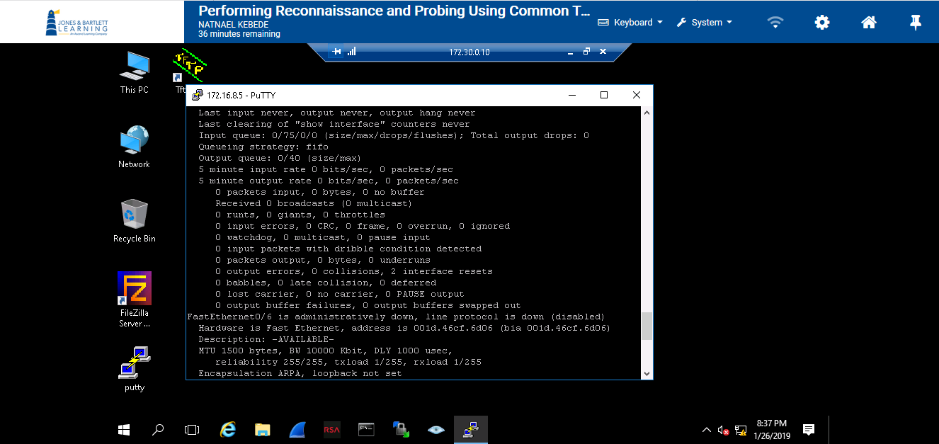
- Screen shot showing the recorder results while using the show ip interface Cisco command In PuTTy terminal consule
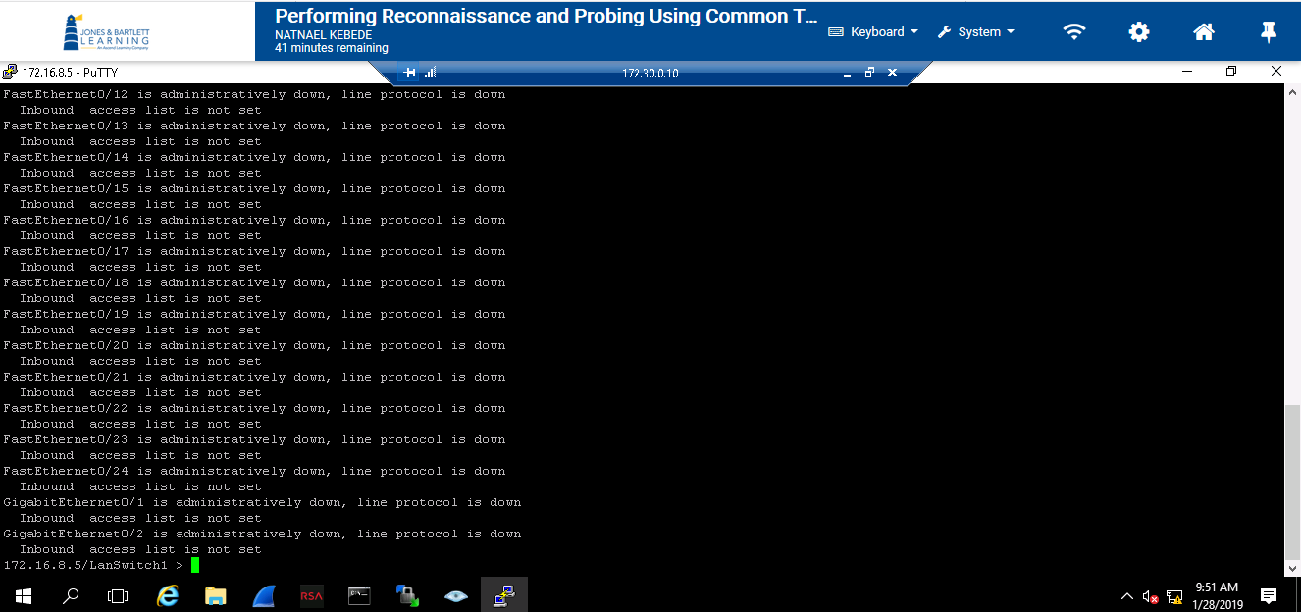

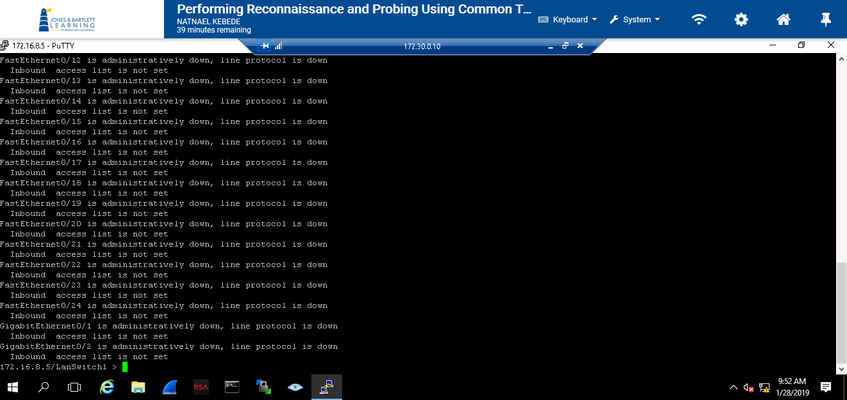

- Screen shot showing the recorder results while using the show ip route Cisco command In PuTTy terminal consule

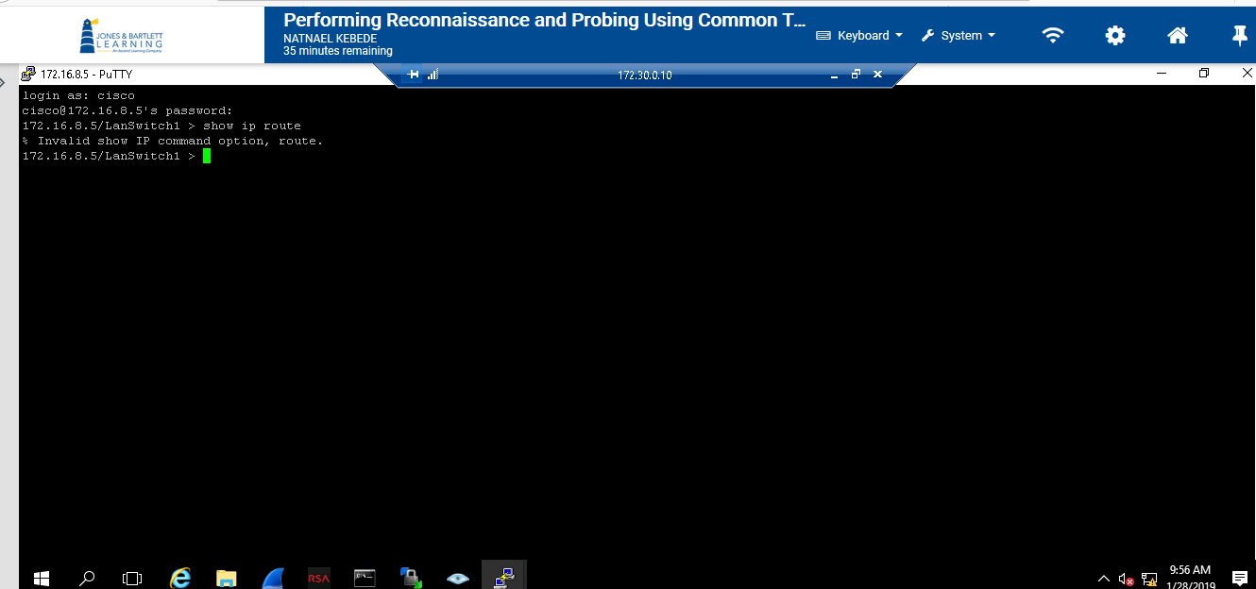
- Screen shot showing the recorder results while using the show vlan Cisco command In PuTTy terminal consule
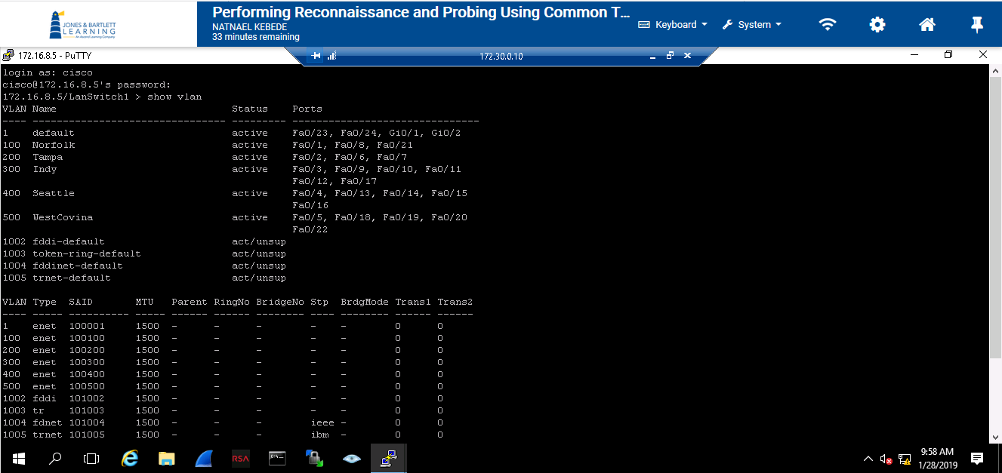

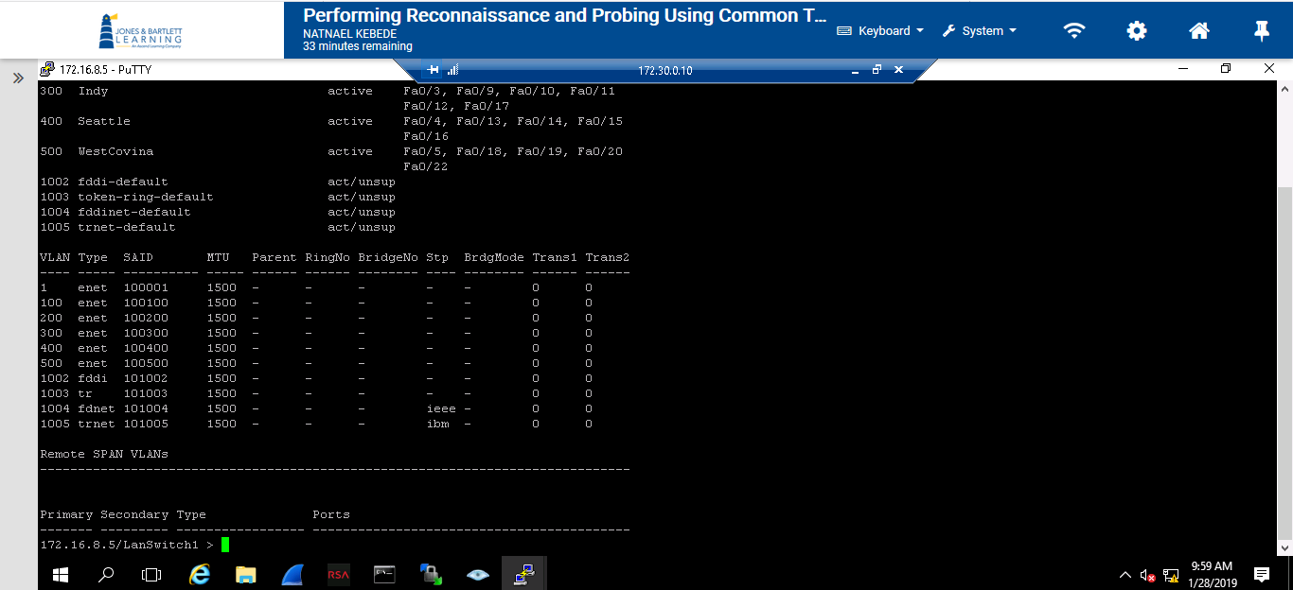
- Screenshot showing the recorder results while using the show ip arp Cisco command In PuTTy terminal consule

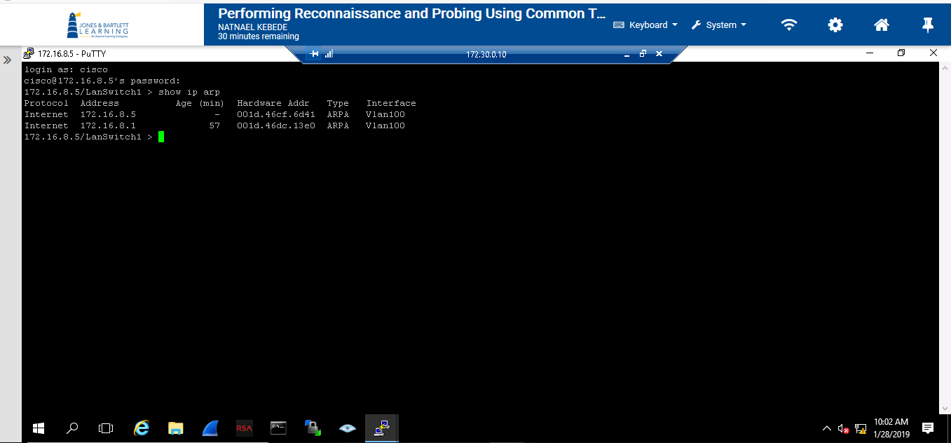

- Screenshot showing the scan of the virtual lab environment using ping scan performed by Zenmap
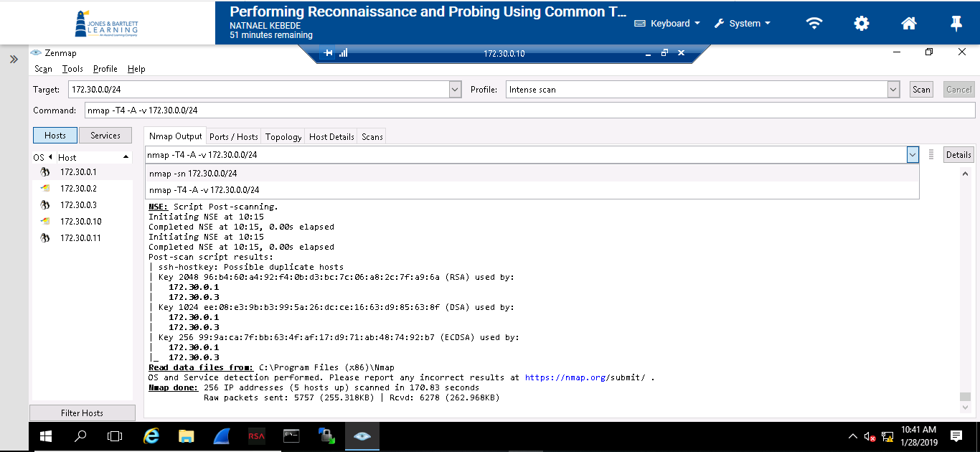

- Screenshot showing the scan of the virtual lab environment using intense scan performed by Zenmap
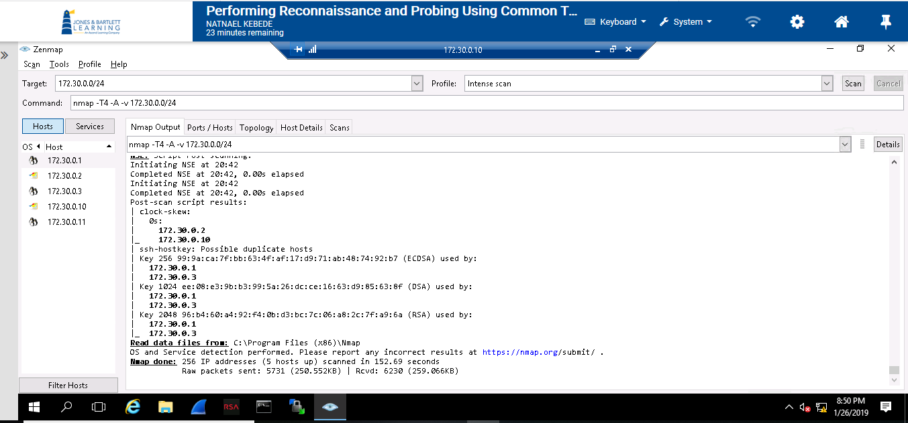

- Screenshot showing a fisheye bubble chart that depicts all the IP hosts discovered during the scan
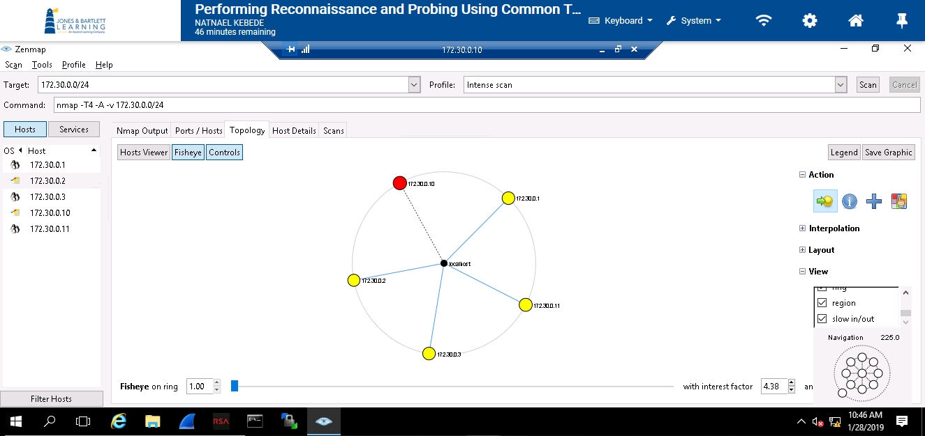

Section 2
- Screen capture showing the arrival time of the the ICMP traffic in Wireshark

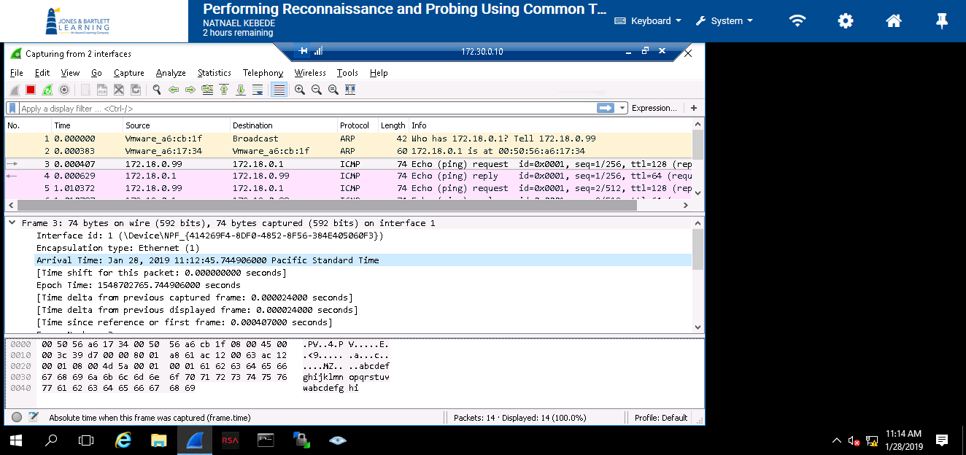

- Screen capture showing the creditcards.txt file details in NetWitness Investigator window
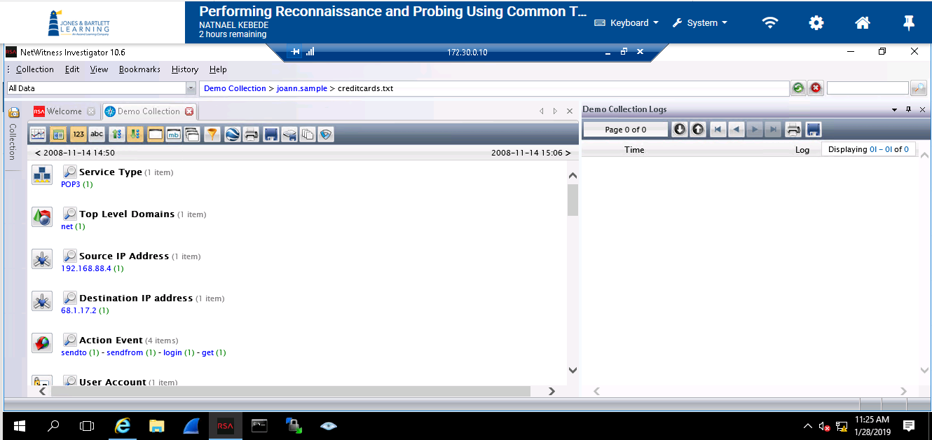

- Screen capture showing the vulnerability detail screen in Nessus
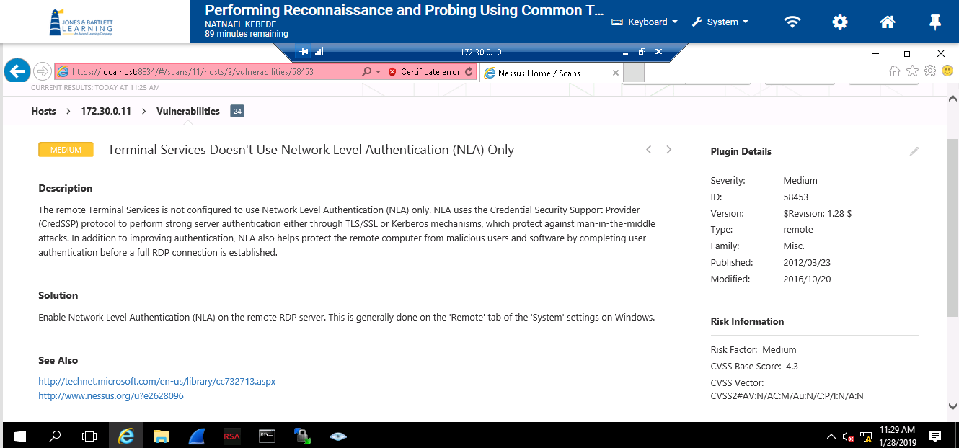

- Screen capture showing a successful TFTP file transfer
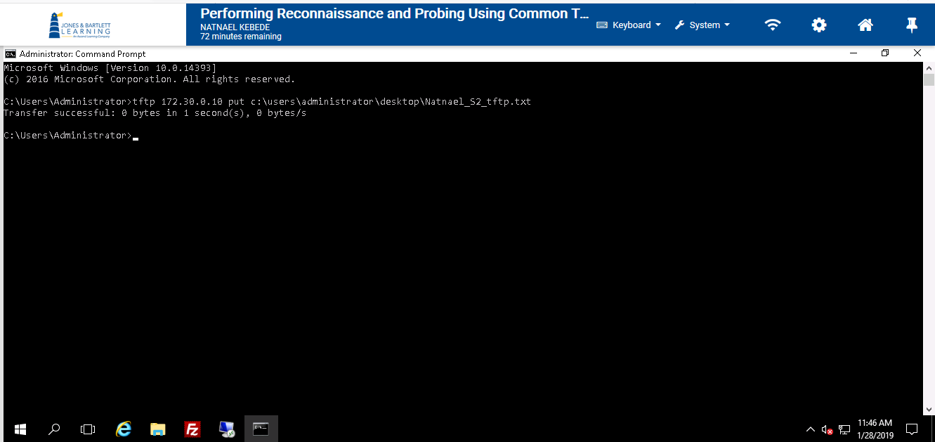
- Scree capture showing the output from the Vlan cisco command
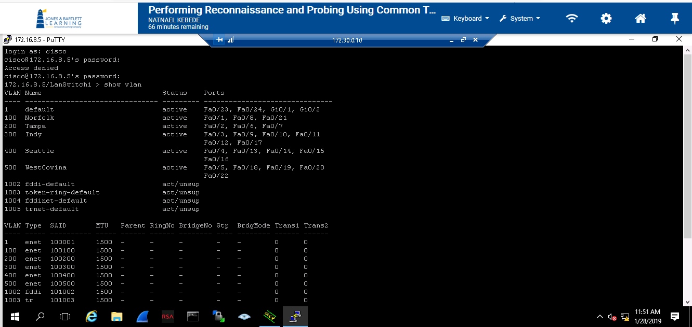
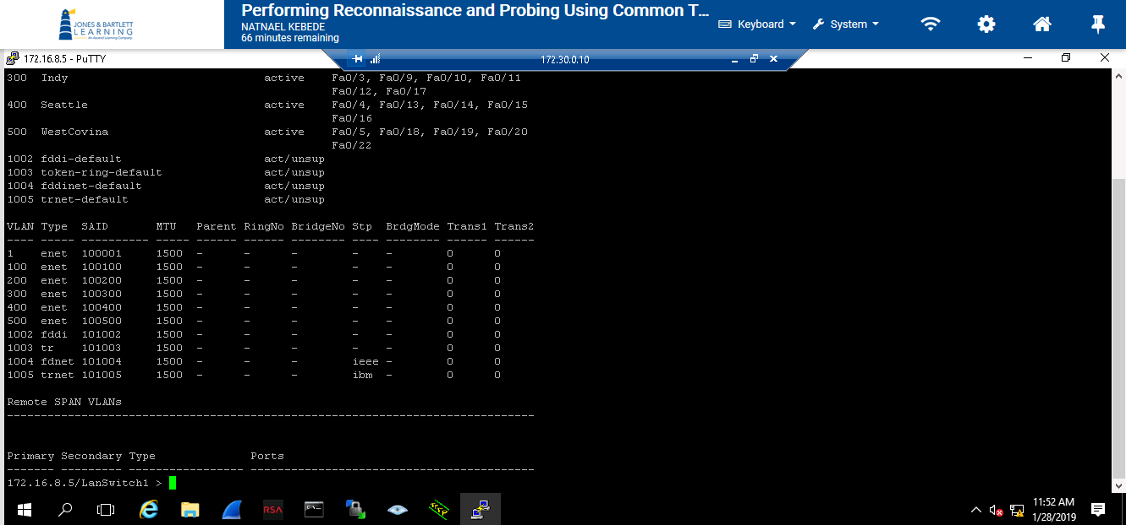
- Screen capture showing Fisheye bubble shart for scan results uiing intense scan on tragets 172.30.0.3 and 172.30.0.11
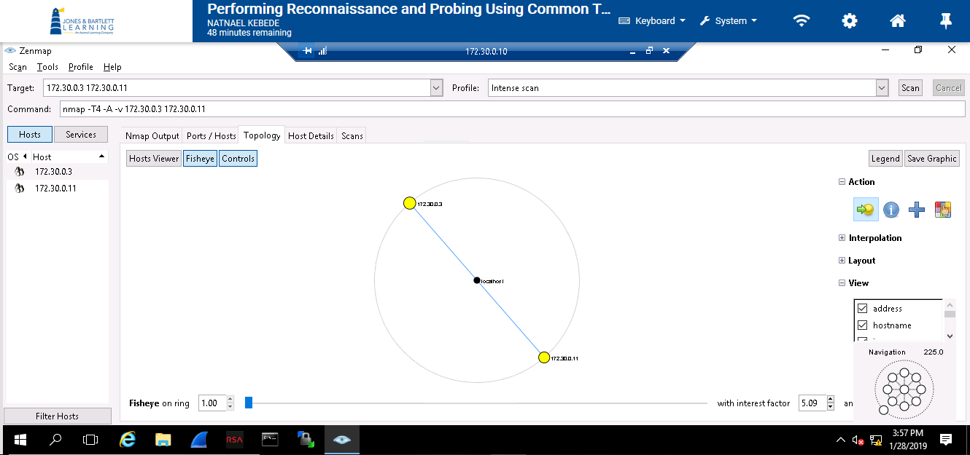

- Scren capture showing Zenmap scan result for nmap of target -T4 -A -F 172.16.8.5 (Quick Scan)
